1. **Project background**

Computer vision analysis of target movement can be roughly divided into three levels: motion segmentation, target detection; target tracking; motion recognition, behavior description. Among them, target detection is not only one of the basic tasks to be solved in the field of computer vision, but also the basic task of video surveillance technology. Because the targets in the video have different poses, often appear occluded, and their motion is irregular, taking into account the depth of field, resolution, weather, lighting and other conditions of the monitored video and the diversity of the scene, and the results of the target detection algorithm will directly Affects subsequent tracking, motion recognition, and behavior description effects. Therefore, even with the development of technology today, the basic task of target detection is still a very challenging subject, and there is great potential and space for improvement.

The analysis of target movement by computer vision is a popular direction of image processing. It is widely used in many fields such as intelligent video surveillance, industrial inspection, aerospace, etc. It is of great practical significance to reduce the consumption of human capital through computer vision. Therefore, this direction has become a research hot spot in theory and application in recent years. It is the core part of intelligent monitoring systems. At the same time, the analysis of motion is also a basic algorithm in the field of universal identity recognition. Recognition, crowd counting, instance segmentation and other tasks play a vital role.

For example, about 5 hours of data content will be uploaded to YouTube every second, so it is very difficult or impossible to manually annotate and classify each video. Computer vision is an important solution to this problem. Technology that tags, classifies, and processes every frame of a video.

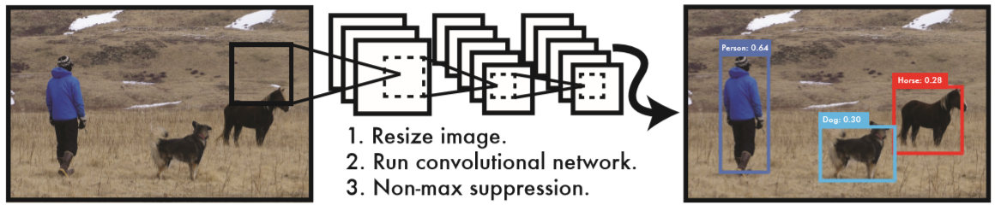

**Figure 1: The YOLO Detection System.**

In addition, the analysis of target motion by computer vision also involves many different fields such as engineering, physics, and biology, such as drones, unmanned driving, and visual navigation of handling robots.

2.Project Overview

This section explains the framework of a distributed system. In our distributed image recognition project, we use both Alibaba Cloud and Huawei Cloud.

We implemented deep learning image recognition based on distributed system architecture. By training twenty kinds of images of person, car, bus, track, motorbike and trafficlight and so on, and processing service requests through multiple servers, we obtained approximate ideal image recognition.

Figure 5 shows our distributed system architecture.

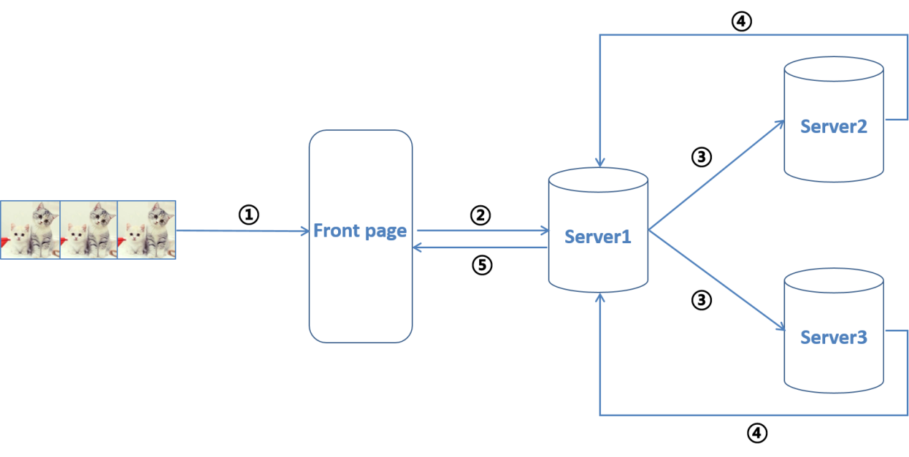

**Figure 2: The Distributed System.**

The intermediate server is used to process the front-end user request, and the server 2 and the server 3 are respectively the Alibaba Cloud server and the Huawei cloud server, and participate in the image recognition work.

Regarding the flow of data information in a distributed system, we will explain it through Figure 6.

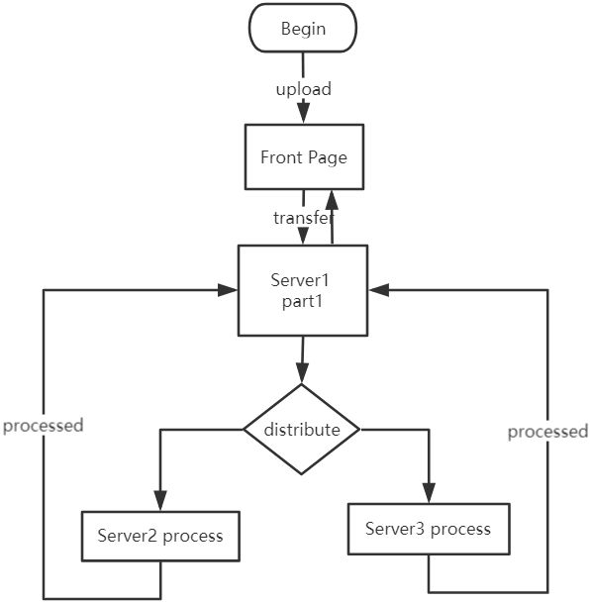

**Figure 3: Data Flow Diagram.**

The front end transmits the image to be identified to the intermediate server, and the intermediate server determines which server the video or video should be forwarded through a load balancing policy.